SQL PROJECT
Name:Sujal Shetty
ROLL.NO:31
Subject:Pl/SQL
Topic:Hotel database

Database name-Vihangs_inn
Entities:
1.Employee:
Attributes:
- E_id*
- E_name
- E_dob
- Date_of_joining
- Gender
- Mobile_no
- Shifts
- Salary
- room_id#
- d_id#
2.Bill
Attributes:
- Bill_id*
- Amount
- Date
- Mode
3.Customers
Attributes:
- Cust_id*
- Cust_name
- dob
- Gender
- Address
- Date_of_checkin
- Date_of_checkout
- room_id#
- Bill_id#
4.Department
Attributes:
- d_id*
- d_name
- Phone_no
- Floor
- Open_hrs
- Close_hrs
5.Room
Attributes:
- room_id*
- Floor
- Type
- Charges
- Availability
- d_id#
ERD DIAGRAM:
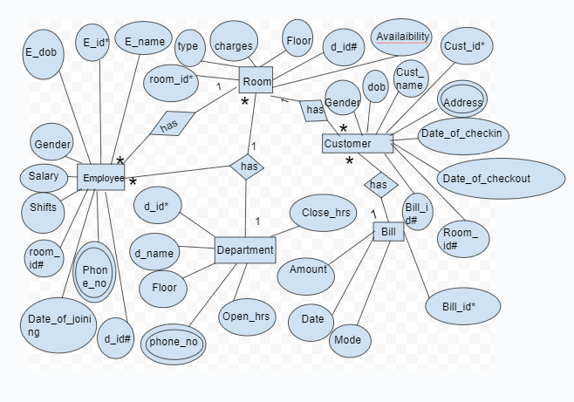
1.
Create database Vihangs_inn;
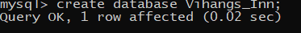
2.
Use Vihangs_inn;
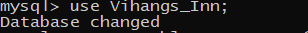

3.
Create table Department(
d_id int not null,
d_name varchar(30) not null,
Phone_no bigint not null,
Floor varchar(20) not null,
Open_hrs varchar(30) not null,
Close_hrs varchar(30) not null,
check(Phone_no<=9999999999 and Phone_no>=100000000),
Primary key(d_id)
);
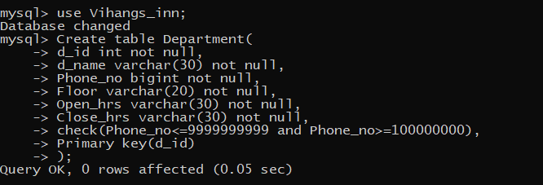
4.
Create table Room(
room_id int not null,
Floor varchar(20) not null,
Type varchar(40) not null,
Charges int not null,
Availability varchar(30) not null,
d_id int not null,
Primary key (room_id),
Foreign key(d_id) references Department(d_id)
);
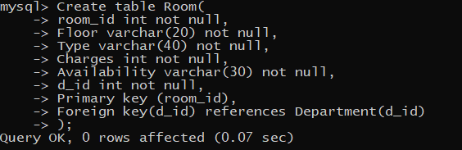
5.
Create table Bill(
Bill_id int not null,
Amount int not null,
Date date,
Mode varchar(30) not null,
Primary key(Bill_id)
);
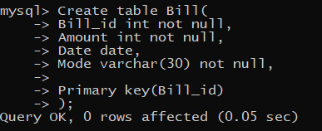
6.
Create table Customers(
Cust_id int not null,
Cust_name varchar(50),
dob date,
Gender varchar(8) not null,
Address varchar(50) not null,
Date_of_checkin date,
Date_of_checkout date,
room_id int not null,
Bill_id int not null,
Primary key(Cust_id),
Foreign key(room_id) references Room(room_id),
Foreign key(Bill_id) references Bill(Bill_id)
);
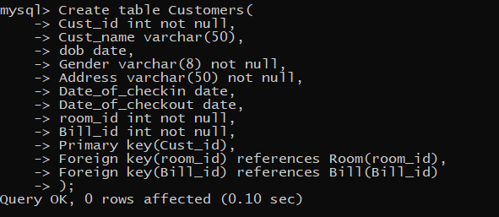
7.
create table Employee(
E_id int not null,
E_name varchar(50) not null,
E_dob date,
Date_of_joining date,
Gender varchar(8) not null,
Mobile_no bigint not null,
Shifts varchar(30) not null,
Salary int not null,
room_id int ,
d_id int not null,
check(Mobile_no<=9999999999 and Mobile_no>=1000000000),
Primary key(E_id),
Foreign key(room_id) references Room(room_id),
Foreign Key(d_id) references Department(d_id)
);

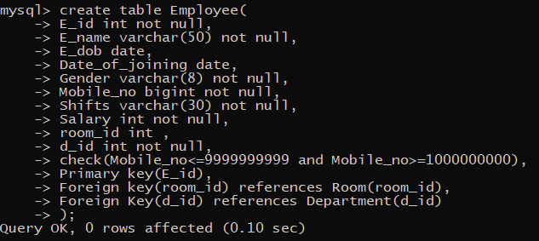
8.
INSERT INTO Department(d_id, d_name, Phone_no, Floor, Open_hrs, Close_hrs) VALUES
(1, 'Reception', 9876543210, 'Ground floor', '6am', '11pm');

INSERT INTO Department(d_id, d_name, Phone_no, Floor, Open_hrs, Close_hrs) VALUES
(2, 'Housekeeping', 9876543211, '1st floor', '8am', '8pm');

INSERT INTO Department(d_id, d_name, Phone_no, Floor, Open_hrs, Close_hrs) VALUES
(3, 'Catering', 9876543212, '2nd floor', '7am', '10pm');

INSERT INTO Department(d_id, d_name, Phone_no, Floor, Open_hrs, Close_hrs) VALUES
(4, 'Maintenance', 9876543213, '3rd floor', '9am', '5pm');

INSERT INTO Department(d_id, d_name, Phone_no, Floor, Open_hrs, Close_hrs) VALUES
(5, 'Security', 9876543214, 'Ground floor', '24hrs', '24hrs');

INSERT INTO Department(d_id, d_name, Phone_no, Floor, Open_hrs, Close_hrs) VALUES
(6, 'Laundry', 9876543215, 'Basement', '10am', '7pm');

INSERT INTO Department(d_id, d_name, Phone_no, Floor, Open_hrs, Close_hrs) VALUES
(7, 'Spa', 9876543216, '2nd floor', '10am', '8pm');

INSERT INTO Department(d_id, d_name, Phone_no, Floor, Open_hrs, Close_hrs) VALUES
(8, 'Gym', 9876543217, '3rd floor', '6am', '10pm');

INSERT INTO Department(d_id, d_name, Phone_no, Floor, Open_hrs, Close_hrs) VALUES
(9, 'Pool', 9876543218, 'Ground floor', '7am', '9pm');

INSERT INTO Department(d_id, d_name, Phone_no, Floor, Open_hrs, Close_hrs) VALUES
(10, 'Parking', 9876543219, 'Basement', '24hrs', '24hrs');
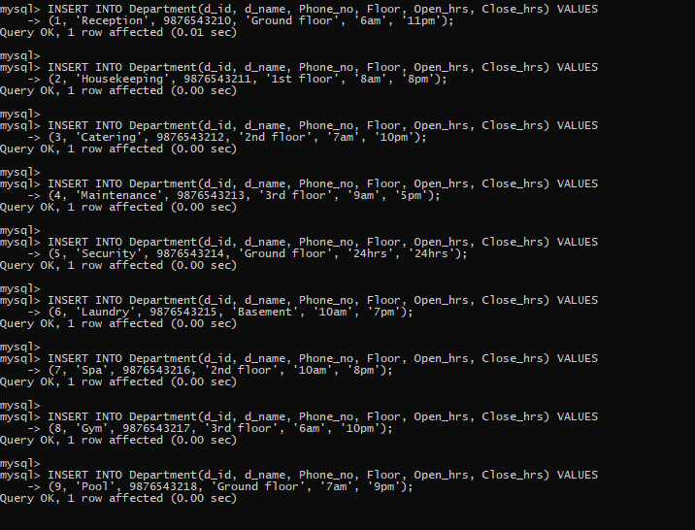
9.
INSERT INTO Room(room_id, Floor, Type, Charges, Availability, d_id) VALUES
(1, '1st floor', 'Studio', 100, 'Vacant', 1);

INSERT INTO Room(room_id, Floor, Type, Charges, Availability, d_id) VALUES
(2, '2nd floor', 'Family room', 200, 'Reserved', 2);

INSERT INTO Room(room_id, Floor, Type, Charges, Availability, d_id) VALUES
(3, '3rd floor', 'Executive suite', 300, 'Booked', 3);

INSERT INTO Room(room_id, Floor, Type, Charges, Availability, d_id) VALUES
(4, '1st floor', 'Presidential suite', 400, 'Vacant', 4);

INSERT INTO Room(room_id, Floor, Type, Charges, Availability, d_id) VALUES
(5, '2nd floor', 'Studio', 150, 'Reserved', 5);

INSERT INTO Room(room_id, Floor, Type, Charges, Availability, d_id) VALUES
(6, 'Ground floor', 'Executive suite', 250, 'Booked', 6);

INSERT INTO Room(room_id, Floor, Type, Charges, Availability, d_id) VALUES
(7, '3rd floor', 'Presidential suite', 350, 'Vacant', 7);

INSERT INTO Room(room_id, Floor, Type, Charges, Availability, d_id) VALUES
(8, '1st floor', 'Studio', 120, 'Reserved', 8);

INSERT INTO Room(room_id, Floor, Type, Charges, Availability, d_id) VALUES
(9, '2nd floor', 'Family room', 220, 'Booked', 9);

INSERT INTO Room(room_id, Floor, Type, Charges, Availability, d_id) VALUES
(10, '3rd floor', 'Executive suite', 320, 'Vacant', 10);
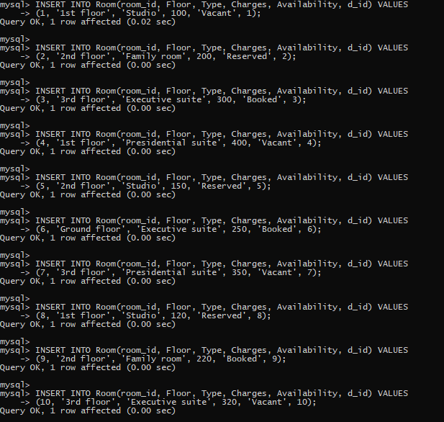
10.
INSERT INTO Bill(Bill_id, Amount, Date, Mode) VALUES
(1, 150, '2023-10-01', 'Cash');

INSERT INTO Bill(Bill_id, Amount, Date, Mode) VALUES
(2, 250, '2023-10-02', 'Online payment');

INSERT INTO Bill(Bill_id, Amount, Date, Mode) VALUES
(3, 350, '2023-10-03', 'Credit Card');

INSERT INTO Bill(Bill_id, Amount, Date, Mode) VALUES
(4, 450, '2023-10-04', 'Debit Card');

INSERT INTO Bill(Bill_id, Amount, Date, Mode) VALUES
(5, 550, '2023-10-05', 'Cheque');

INSERT INTO Bill(Bill_id, Amount, Date, Mode) VALUES
(6, 150, '2023-10-06', 'Cash');

INSERT INTO Bill(Bill_id, Amount, Date, Mode) VALUES
(7, 250, '2023-10-07', 'Online payment');

INSERT INTO Bill(Bill_id, Amount, Date, Mode) VALUES
(8, 350, '2023-10-08', 'Credit Card');

INSERT INTO Bill(Bill_id, Amount, Date, Mode) VALUES
(9, 450, '2023-10-09', 'Debit Card');

INSERT INTO Bill(Bill_id, Amount, Date, Mode) VALUES
(10, 550, '2023-10-10', 'Cheque');
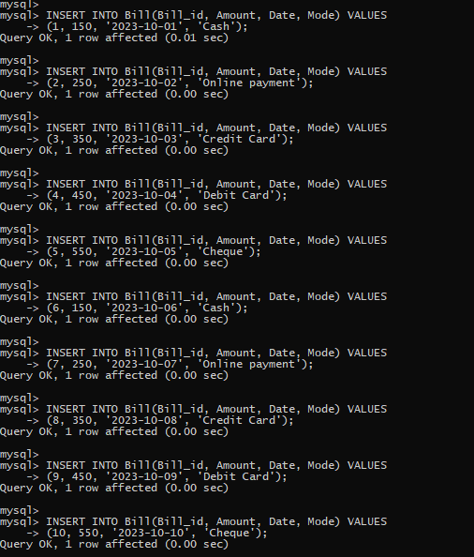
11.
INSERT INTO Customers(Cust_id, Cust_name, dob, Gender, Address, Date_of_checkin, Date_of_checkout, room_id, Bill_id) VALUES
(1, 'John Doe', '1990-01-01', 'Male', '123 Main St', '2023-10-01', '2023-10-05', 1, 1);
INSERT INTO Customers(Cust_id, Cust_name, dob, Gender, Address, Date_of_checkin, Date_of_checkout, room_id, Bill_id) VALUES
(2, 'Jane Smith', '1992-05-05', 'Female', '456 Elm St', '2023-10-02', '2023-10-06', 2, 2);
INSERT INTO Customers(Cust_id, Cust_name, dob, Gender, Address, Date_of_checkin, Date_of_checkout, room_id, Bill_id) VALUES
(3, 'Alice Brown', '1993-02-02', 'Female', '789 Maple St', '2023-10-03', '2023-10-07', 3, 3);
INSERT INTO Customers(Cust_id, Cust_name, dob, Gender, Address, Date_of_checkin, Date_of_checkout, room_id, Bill_id) VALUES
(4, 'Bob White', '1989-12-12', 'Male', '101 Pine St', '2023-10-04', '2023-10-08', 4, 4);
INSERT INTO Customers(Cust_id, Cust_name, dob, Gender, Address, Date_of_checkin, Date_of_checkout, room_id, Bill_id) VALUES
(5, 'Charlie Green', '1995-03-03', 'Male', '202 Oak St', '2023-10-05', '2023-10-09', 5, 5);
INSERT INTO Customers(Cust_id, Cust_name, dob, Gender, Address, Date_of_checkin, Date_of_checkout, room_id, Bill_id) VALUES
(6, 'Daisy Black', '1988-04-04', 'Female', '303 Birch St', '2023-10-06', '2023-10-10', 6, 6);
INSERT INTO Customers(Cust_id, Cust_name, dob, Gender, Address, Date_of_checkin, Date_of_checkout, room_id, Bill_id) VALUES
(7, 'Ella Grey', '1994-06-06', 'Female', '404 Cedar St', '2023-10-07', '2023-10-11', 7, 7);
INSERT INTO Customers(Cust_id, Cust_name, dob, Gender, Address, Date_of_checkin, Date_of_checkout, room_id, Bill_id) VALUES
(8, 'Frank Red', '1987-07-07', 'Male', '505 Dogwood St', '2023-10-08', '2023-10-12', 8, 8);
INSERT INTO Customers(Cust_id, Cust_name, dob, Gender, Address, Date_of_checkin, Date_of_checkout, room_id, Bill_id) VALUES
(9, 'Grace Blue', '1996-08-08', 'Female', '606 Fir St', '2023-10-09', '2023-10-13', 9, 9);
INSERT INTO Customers(Cust_id, Cust_name, dob, Gender, Address, Date_of_checkin, Date_of_checkout, room_id, Bill_id) VALUES
(10, 'Henry Yellow', '1986-09-09', 'Male', '707 Spruce St', '2023-10-10', '2023-10-14', 10, 10);
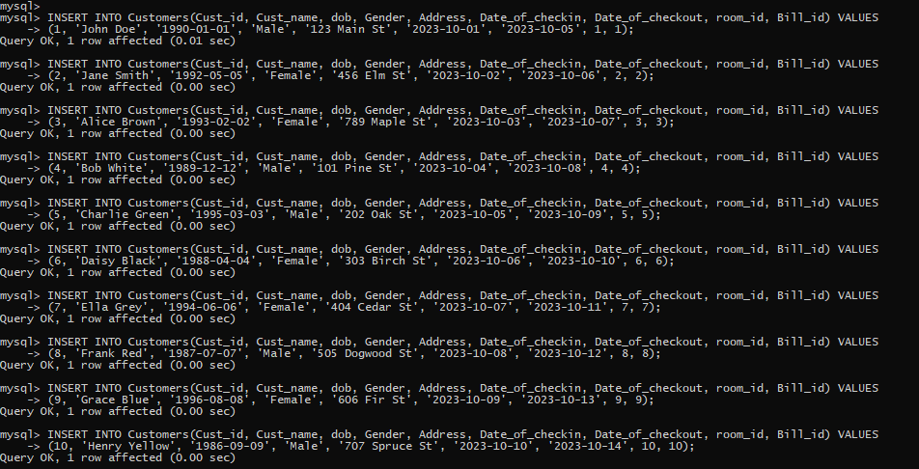
12.
INSERT INTO Employee(E_id, E_name, E_dob, Date_of_joining, Gender, Mobile_no, Shifts, Salary, room_id, d_id) VALUES
(1, 'Mike', '1985-01-15', '2019-01-01', 'Male', 9123456780, '8am-5pm', 1000, 1, 1);
INSERT INTO Employee(E_id, E_name, E_dob, Date_of_joining, Gender, Mobile_no, Shifts, Salary, room_id, d_id) VALUES
(2, 'Linda', '1987-02-20', '2020-02-02', 'Female', 9123456781, '9am-6pm', 1100, 2, 2);
INSERT INTO Employee(E_id, E_name, E_dob, Date_of_joining, Gender, Mobile_no, Shifts, Salary, room_id, d_id) VALUES
(3, 'Oscar', '1980-03-25', '2018-03-03', 'Male', 9123456782, '1pm-10pm', 1200, 3, 3);
INSERT INTO Employee(E_id, E_name, E_dob, Date_of_joining, Gender, Mobile_no, Shifts, Salary, room_id, d_id) VALUES
(4, 'Eva', '1982-04-30', '2017-04-04', 'Female', 9123456783, '7am-4pm', 1300, 4, 4);
INSERT INTO Employee(E_id, E_name, E_dob, Date_of_joining, Gender, Mobile_no, Shifts, Salary, room_id, d_id) VALUES
(5, 'Tom', '1983-05-05', '2016-05-05', 'Male', 9123456784, '10am-7pm', 1400, 5, 5);
INSERT INTO Employee(E_id, E_name, E_dob, Date_of_joining, Gender, Mobile_no, Shifts, Salary, room_id, d_id) VALUES
(6, 'Sophia', '1986-06-10', '2015-06-06', 'Female', 9123456785, '2pm-11pm', 1500, 6, 6);
INSERT INTO Employee(E_id, E_name, E_dob, Date_of_joining, Gender, Mobile_no, Shifts, Salary, room_id, d_id) VALUES
(7, 'Charlie', '1988-07-15', '2014-07-07', 'Male', 9123456786, '6am-3pm', 1600, 7, 7);
INSERT INTO Employee(E_id, E_name, E_dob, Date_of_joining, Gender, Mobile_no, Shifts, Salary, room_id, d_id) VALUES
(8, 'Olivia', '1981-08-20', '2013-08-08', 'Female', 9123456787, '3pm-12am', 1700, 8, 8);
INSERT INTO Employee(E_id, E_name, E_dob, Date_of_joining, Gender, Mobile_no, Shifts, Salary, room_id, d_id) VALUES
(9, 'David', '1984-09-25', '2012-09-09', 'Male', 9123456788, '9pm-6am', 1800, 9, 9);
INSERT INTO Employee(E_id, E_name, E_dob, Date_of_joining, Gender, Mobile_no, Shifts, Salary, room_id, d_id) VALUES
(10, 'Emma', '1989-10-30', '2011-10-10', 'Female', 9123456789, '11pm-8am', 1900, 10, 10);
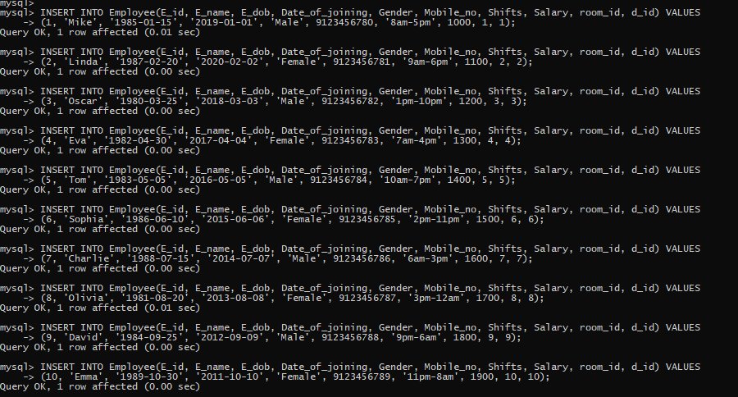
13.
Select* from Department;
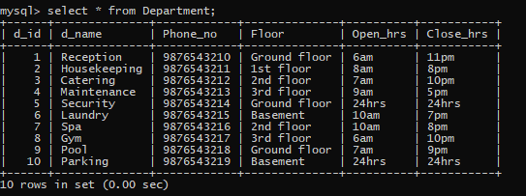
14.
Select * from Room;
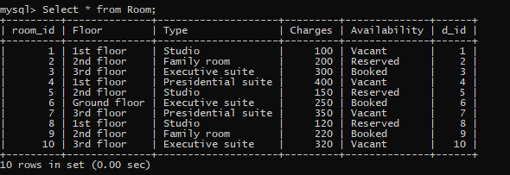
15.
Select * from Bill;
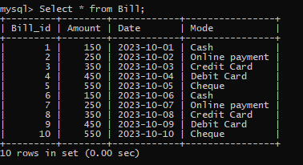
16.
Select * from Customers;
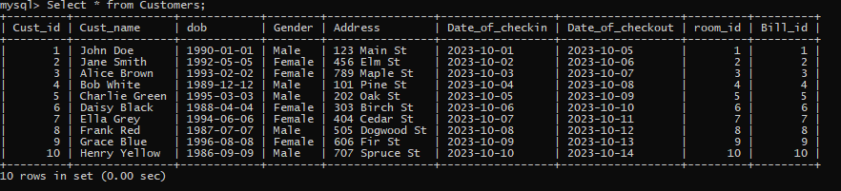
17.
Select * from Employee;
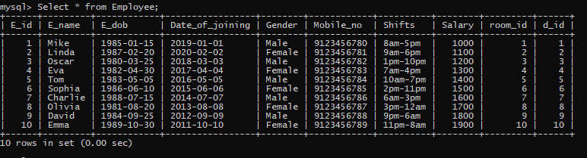
18.
select Avg(Salary) as "Average Salary of Employees" from Employee;
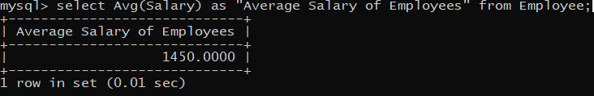
19.
select floor(DATEDIFF(CURDATE(),E_dob)/365) as "AGE" from Employee;
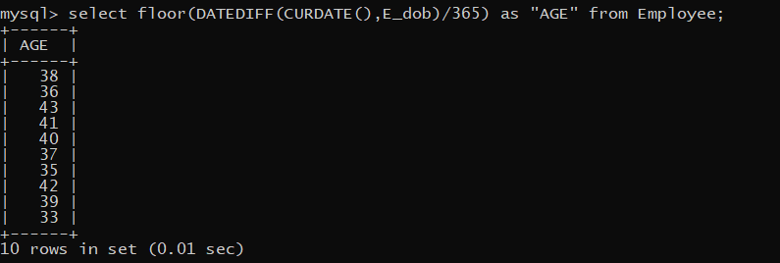
20.
select sum(Salary) from Employee;
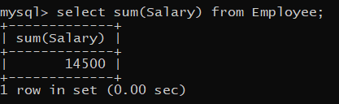
21.
select floor(DATEDIFF(CURDATE(),dob)/365) as "AGE" from Customers;
